**Swinburne University of Technology**

### School of Science Technology and Engineering

## Mini Project 3

Lab commences in week 8. Report is due by Monday 15th of May at 4:00 pm in my mailbox on the 7th floor of EN building.

**Preliminary Work:**

1. Write a source VHDL to describe the circuit in Figure 1 (2 marks)
2. Write a source code to generate the 16-bit pseudo random number (PRN) generators in part 2. (3 marks)

**Part 1: Design of a RANDOM-ACCESS MEMORY EMULATOR**

The following sequential circuit represents a memory with 8 addresses, where each address holds a 4-bit data. The memory positions are implemented using 4-bit registers. The reset and clock signals are shared by all the registers. Data is written or read onto/from one of the registers (selected by the signal ‘address’).

* Writing onto memory (wr_rd = 1): The 4-bit input data (D_in) is written into one of the 8 registers. The address signal selects which register is to be written. Here, the 7-segment display must show 0. For example: if address = “101”, then D_in is written into register 5.
* Reading from memory (wr_rd = 0): The MUX output appears on the 7-segment display (hexadecimal value). The address signal selects the register from which data is read. For example: If address = “010”, then data in register 2 must appear on the 7-segment display. If data in register 2 is ‘1010’, then the symbol ‘A’ appears on the 7-segment display.

*Hint: please refer to lecture slides on memory elements slides 100-105 in topic 3 Behavioural Modeling.*



Figure 1

**Lab Work for Part 1**: Verify the operation of the circuit via simulation. Make sure to cover all the functional requirements.

Part 2: **Design of a** **Pseudo** **Random Number** (PRN) **Generator**

PURPOSE – In this part of the laboratory you will design and implement two Linear feedback Shift Registers (LFSR) to generate pseudo random number generators.

a. Develop a source VHDL code to design the random number generator that can generate a 16-bit number sequence. (Please refer to the polynomial below). The initial conditions are loaded on reset (initial starting count). If start is set to ‘1’ the then the pseudo random generator generates a” random sequence” and when start is set to zero it stops and holds on to the last value in the sequence002E

Start

clock

*Pseudo random generator*

Q (16 bits)

reset

**P’**

P1(x) = **x16 + x15 + x11 + x9 + x8 + x7 + x5 + x4 + x2 + x1 + 1**

Reference: Topic: Design for Testability Module: slides 100-127

**Lab Work for Part 2**

(1) Verify via simulation the operation of the pseudo random number (PRN) generator. Note the maximum clock frequency and the hardware requirements.

**Report**

**Hand in**

1. Provide the VHDL source code for part 1. Include the signal generation stimulus, simulation results, hardware requirements, and maximum clock frequency (include the FPGA chip which was used). Ensure that you provide verification of all the functional requirements.

Part 1 VHDL Code

library ieee;

use ieee.std_logic_1164.all;

use ieee.numeric_std.all;

entity memory is

port (

clk : in std_logic;

rst : in std_logic;

wr_rd : in std_logic;

address : in std_logic_vector(2 downto 0);

din : in std_logic_vector(3 downto 0);

seg : out std_logic_vector(6 downto 0)

);

end entity;

architecture rtl of memory is

type memory_array is array (0 to 7) of std_logic_vector(3 downto 0);

signal mem : memory_array := (others => "0000");

signal mux_out : std_logic_vector(3 downto 0);

begin

process (clk, rst)

begin

if rst = '1' then

mem <= (others => "0000");

elsif rising_edge(clk) then

if wr_rd = '1' then -- Write mode

mem(to_integer(unsigned(address))) <= din;

seg <= "0000000";

else -- Read mode

mux_out <= mem(to_integer(unsigned(address)));

case mux_out is

when "0000" => seg <= "0000001"; -- 0

when "0001" => seg <= "1001111"; -- 1

when "0010" => seg <= "0010010"; -- 2

when "0011" => seg <= "0000110"; -- 3

when "0100" => seg <= "1001100"; -- 4

when "0101" => seg <= "0100100"; -- 5

when "0110" => seg <= "0100000"; -- 6

when "0111" => seg <= "0001111"; -- 7

when "1000" => seg <= "0000000"; -- 8

when "1001" => seg <= "0000100"; -- 9

when "1010" => seg <= "0001000"; -- A

when "1011" => seg <= "1100000"; -- B

when "1100" => seg <= "0110001"; -- C

when "1101" => seg <= "1000010"; -- D

when "1110" => seg <= "0110000"; -- E

when others => seg <= "0111000"; -- F

end case;

end if;

end if;

end process;

end architecture;

Part 1 Testbench

library ieee;

use ieee.std_logic_1164.all;

entity memory_tb is

end entity;

architecture test of memory_tb is

-- Component declaration

component memory is

port (

clk : in std_logic;

rst : in std_logic;

wr_rd : in std_logic;

address : in std_logic_vector(2 downto 0);

din : in std_logic_vector(3 downto 0);

seg : out std_logic_vector(6 downto 0)

);

end component;

-- Signals declaration

signal clk : std_logic := '0';

signal rst : std_logic := '0';

signal wr_rd : std_logic;

signal address : std_logic_vector(2 downto 0);

signal din : std_logic_vector(3 downto 0);

signal seg : std_logic_vector(6 downto 0);

begin

-- Instantiate the memory component

uut: memory port map (

clk => clk,

rst => rst,

wr_rd => wr_rd,

address => address,

din => din,

seg => seg

);

-- Clock generation

process

begin

clk <= '0';

wait for 5 ns;

clk <= '1';

wait for 5 ns;

end process;

-- Stimulus process

process

begin

-- Perform a reset

rst <= '1';

wait for 100 ns;

rst <= '0';

wait for 100 ns;

-- Write some values to memory

wr_rd <= '1';

address <= "000";

din <= "0010";

wait for 10 ns;

address <= "010";

din <= "1010";

wait for 10 ns;

address <= "111";

din <= "0100";

wait for 10 ns;

-- Read values from memory

wr_rd <= '0';

address <= "000";

wait for 10 ns;

address <= "010";

wait for 10 ns;

address <= "111";

wait for 10 ns;

-- End the simulation

wait;

end process;

end architecture;

Part 1 Simulation Results

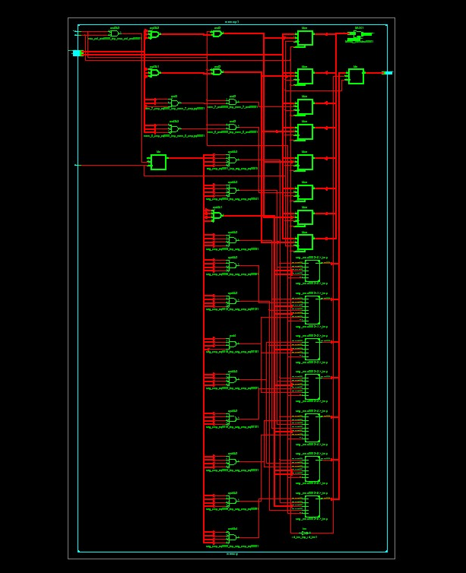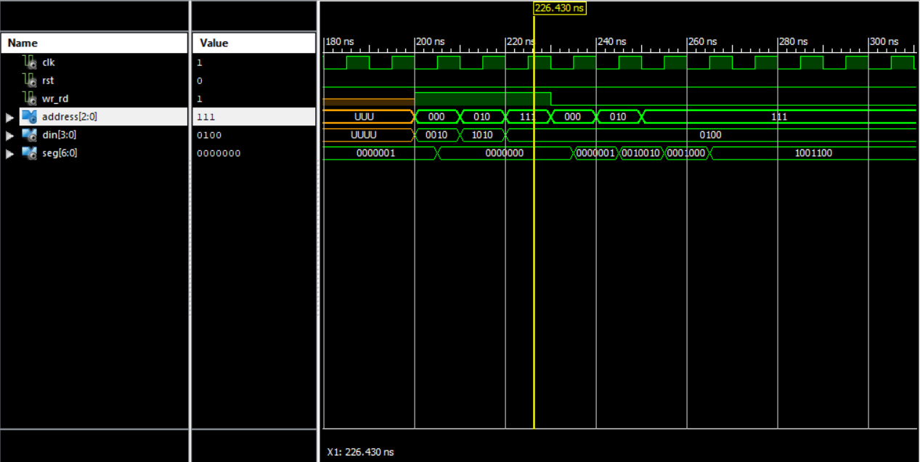

Part 1 Timing Summary:

---------------

Speed Grade: -5

Minimum period: 2.674ns (Maximum Frequency: 373.972MHz)

Minimum input arrival time before clock: 3.931ns

Maximum output required time after clock: 4.040ns

Maximum combinational path delay: No path found

HDL Synthesis Report

Macro Statistics

# Registers : 10

4-bit register : 9

7-bit register : 1

# Multiplexers : 1

4-bit 8-to-1 multiplexer : 1

Verification of working for part 1:

From the simulation we can see the programmed output of the 7seg being “0” (0000001). The later variants of din for the read and write operations, we can see the variation of the 7seg output being correct.

1. Provide the VHDL source code for part 2, Include the signal generation stimulus, simulation results, hardware requirements, and maximum clock frequency ( include the FPGA which was used). Generate simulation results for different initial conditions.
2. library ieee;
3. use ieee.std_logic_1164.all;
4. entity lfsr is
5. port (
6. reset : in std_logic;
7. clock : in std_logic;
8. start : in std_logic;
9. q_out : out std_logic_vector(15 downto 0)
10. );
11. end lfsr;
12. architecture behavior of lfsr is
13. signal reg : std_logic_vector(15 downto 0);
14. begin
15. process(clock, reset)
16. begin
17. if reset = '1' then
18. reg <= (others => '1');
19. elsif rising_edge(clock) then
20. if start = '1' then
21. *-- XOR taps*
22. reg <= reg(14 downto 0) &
23. (reg(15) xor reg(13) xor reg(12) xor reg(4));
24. end if;
25. end if;
26. end process;
27. q_out <= reg;
28. end behavior;

Testbench

library ieee;

use ieee.std_logic_1164.all;

entity lfsr_tb is

end lfsr_tb;

architecture testbench of lfsr_tb is

signal clk : std_logic := '0';

signal start : std_logic := '0';

signal reset : std_logic := '1';

signal q_out : std_logic_vector(15 downto 0);

begin

DUT: entity work.lfsr

port map(

clock => clk ,

reset => reset ,

start => start,

q_out => q_out

);

clk <= not clk after 10 ns;

stimulus: process

begin

-- Reset the LFSR

reset <= '1';

wait for 10 ns;

reset <= '0';

wait for 10 ns;

-- Test 1: Start = '0'

start <= '0';

wait for 100 ns;

-- Test 2: Start = '1', generate 10 cycles

start <= '1';

wait for 10 * 10 ns;

start <= '0';

wait for 10 ns;

-- Test 3: Start = '1', generate 100 cycles

start <= '1';

wait for 100 * 10 ns;

start <= '0';

wait for 10 ns;

-- Test 4: Reset during operation

start <= '1';

wait for 20 * 10 ns;

reset <= '1';

wait for 10 ns;

reset <= '0';

wait for 30 * 10 ns;

start <= '0';

-- Wait for some additional cycles

wait for 10 ns;

wait;

end process;

end testbench;

Simulation Results

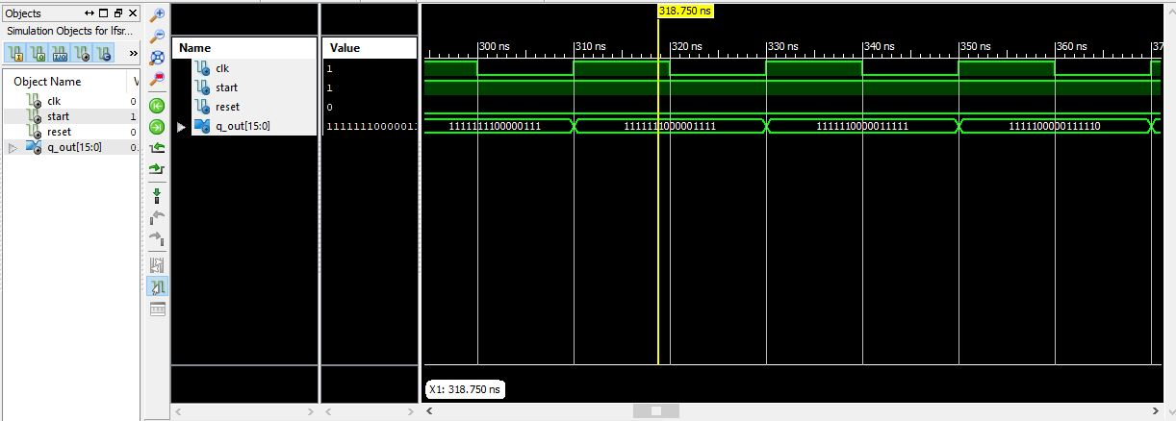

Timing Summary

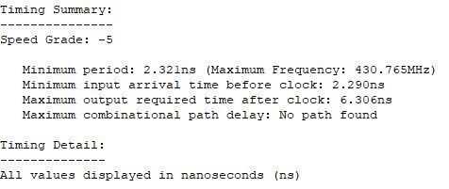

Hardware

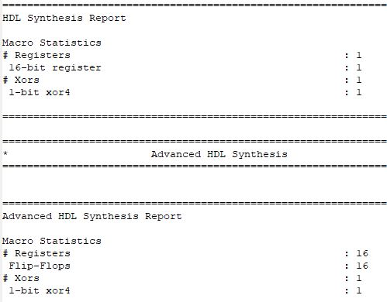

Initial condition

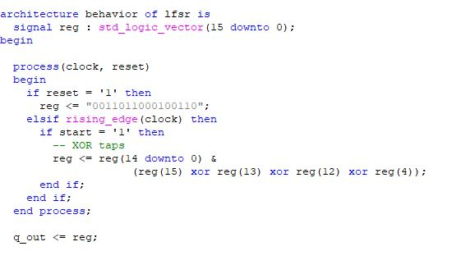

We can see that reg is set to a random 16 digit array. When we see the simulation results below, we get:

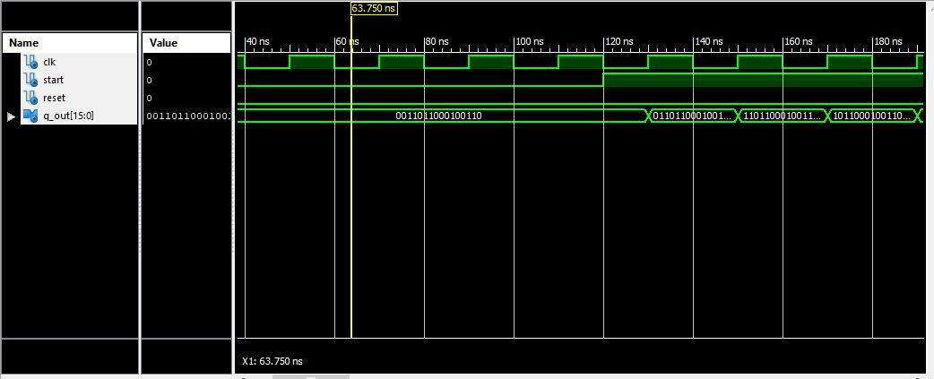

Similiaryly, for another random initial variation, we get different generated random outputs, proving the ability of the lsfr to create semi-random outputs.

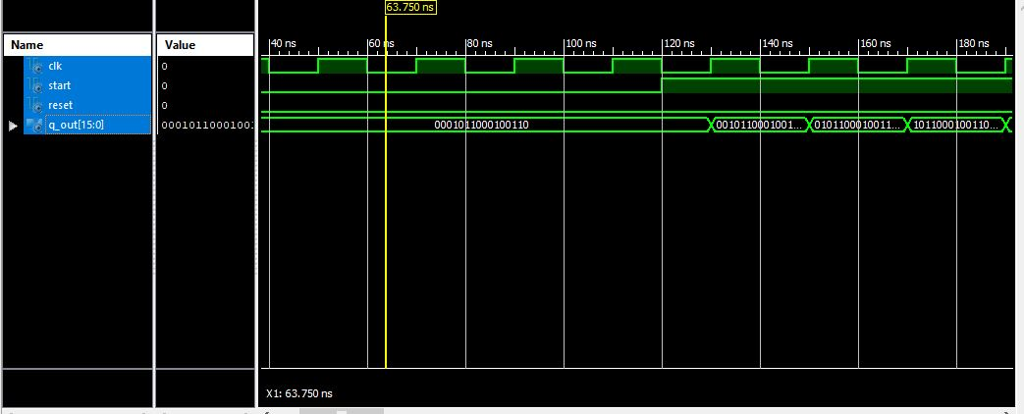

Ismat Hijazin

April 26, 2023